Recipease - Intelligent Recipe Management & Meal Planning System

Page 1: Project Information & Developer Profile

Project Overview
Project Title: Recipease - Full-Stack Recipe Management System
Course: CIS 435 - Web Technology
Semester: Fall 2025
Submission Date: December 7, 2025
Project Type: Individual Full-Stack Web Application
Developer Information
Name: Michael Berry
Role: Full-Stack Developer & Database Architect
Responsibilities: Complete end-to-end development including database design, backend API development, frontend interface creation, and system integration.

Comprehensive Responsibilities

Database Design & Implementation
- Designed and implemented SQLite database schema with proper normalization
- Created recipes and meal_plans tables with appropriate constraints
- Implemented JSON storage for variable-length data (ingredients, instructions)
- Developed comprehensive sample data with 5 diverse recipes
- Backend Development
- Built Node.js/Express.js server with RESTful API endpoints
- Implemented 15+ API endpoints for CRUD operations
- Configured CORS middleware and error handling
- Developed meal planning and grocery list generation logic
- Frontend Development
- Created responsive HTML/CSS/JavaScript interface
- Implemented tab-based navigation system
- Developed drag-and-drop meal planning interface
- Built real-time search and filtering functionality
- System Integration & Testing
- Integrated frontend with backend API
- Implemented comprehensive error handling
- Conducted cross-browser testing
- Ensured data persistence and consistency

Technology Stack
- Frontend: HTML5, CSS3, Vanilla JavaScript
- Backend: Node.js, Express.js
- Database: SQLite3
- Development Tools: Git Bash, VS Code, http-server

Page 2: Design Considerations & Architecture

System Architecture
The application follows a three-tier architecture:
┌─────────────────┐ HTTP/JSON ┌─────────────────┐
│ Frontend ◄─────────►│ Backend API │
│ (Port 8000) │ │ (Port 5000) │
└─────────────────┘ └─────────────────┘
│
▼
┌─────────────────┐
│ SQLite Database │
│ (recipes.db) │
└─────────────────┘

Key Design Decisions
- Single Page Application Design
- Tab-based navigation prevents page reloads
- Modal dialogs for detailed views without navigation
- Real-time updates without full page refresh
- Database Design Considerations
- SQLite chosen for simplicity and zero-configuration
- JSON storage for ingredients/instructions to handle variable lengths
- Foreign key constraints for data integrity between tables
- Indexes on frequently queried columns for performance
- API Design Principles
- RESTful design with appropriate HTTP methods
- JSON as primary data format
- Consistent error response structure
- Proper HTTP status codes implementation

- User Experience Considerations
- Drag-and-drop interface for intuitive meal planning
- Auto-save functionality to prevent data loss
- Real-time feedback for all user actions
- Responsive design for various screen sizes

Database Schema Design
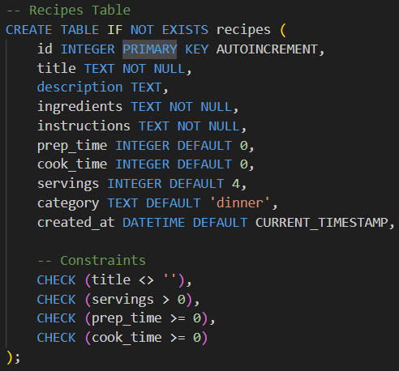
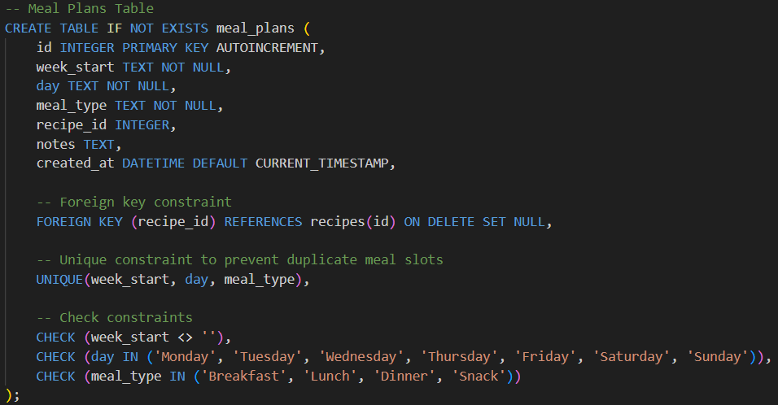

Security & Performance Considerations
- CORS Configuration: Properly configured for development
- Input Validation: Both client-side and server-side validation
- Error Handling: Graceful error messages without exposing system details
- Performance: Database indexes and efficient query design

Page 3: User Interface Design & Prototype

UI Design Philosophy
The interface follows a clean, intuitive design with clear visual hierarchy and consistent interaction patterns.

Main Interface Components
1. Navigation System
┌─────────────────────────────────────────┐
│ [🏠 Dashboard] [📚 Recipes] [➕ Add] │
│ [📅 Meal Plan] [🛒 Grocery] │
└─────────────────────────────────────────┘
- Tab-based navigation with icons for quick recognition
- Active tab highlighting for clear orientation
- Consistent placement across all pages

2. Dashboard Design
┌─────────────────────────────────────────┐
│ 🍳 RECIPEASE - Recipe Manager │
├─────────────────────────────────────────┤
│ ✅ Connected to backend! │
│ │
│ 📊 DASHBOARD STATISTICS │
│ ├─ Total Recipes: 5 │
│ ├─ Avg Prep Time: 18min │
│ ├─ Categories: 4 │
│ └─ Database Status: OK │
│ │
│ ⚡ QUICK ACTIONS │
│ [View All Recipes] [Add New Recipe] │
│ [Test Connection] │
└─────────────────────────────────────────┘
3. Recipe Cards Design
┌─────────────────────────────────────────┐
│ Spaghetti Carbonara │
│ Italian pasta with eggs and bacon │
│ │
│ 🏷️ Dinner | ⏰ 35min | 👥 4 servings │
│ │
│ [👁️ View] [✏️ Edit] [📅 Add to Plan] │
└─────────────────────────────────────────┘
4. Meal Planning Interface
┌─────────────────────────────────────────┐
│ MON TUE WED THU FRI SAT SUN │
├─────────────────────────────────────────┤
│ Breakfast │
│ Lunch │
│ Dinner ┌────────────┐ │
│ │ Recipe │ ← Drag from below │
│ │ Card │ │
│ └────────────┘ │
├─────────────────────────────────────────┤
│ 🍳 AVAILABLE RECIPES (Drag me!) │
│ ┌────┐ ┌────┐ ┌────┐ │
│ │R1 │ │R2 │ │ R3 │ │
│ └────┘ └────┘ └────┘ │
└─────────────────────────────────────────┘

5. Grocery List Interface
┌─────────────────────────────────────────┐
│ 🛒 GROCERY LIST - Week of 2024-W50 │
├─────────────────────────────────────────┤
│ ✅ Shopping Progress: 65% │
│ ██████████░░░░░░░░░░░░░░░░ │
│ │
│ [ ] 2 cups all-purpose flour │
│ [✓] 1 lb spaghetti (checked) │
│ [ ] 4 large eggs │
│ │
│ [🖨️ Print] [✓ Mark All] [↻ Reset] │
└─────────────────────────────────────────┘
Color Scheme & Typography
- Primary Color: #4CAF50 (Green for success/actions)
- Secondary Color: #2196F3 (Blue for information)
- Background: #F5F5F5 (Light gray)
- Text: #333333 (Dark gray for readability)
- Font: System fonts (Arial, sans-serif) for maximum compatibility

Responsive Design Features
- Flexible Grid System: Adapts to different screen sizes
- Mobile-Friendly: Touch targets appropriately sized
- Progressive Enhancement: Core functions work without JavaScript
- Print Styles: Optimized grocery list printing

Page 4: System Components & UML Diagrams

System Components Overview
1. Frontend Components
- index.html: Main application structure with semantic markup
- style.css: Complete styling with responsive design
- script.js: 25+ JavaScript functions handling all application logic
2. Backend Components
- server.js: Express.js server with API endpoints
- package.json: Dependencies and project configuration
- recipes.db: SQLite database file
- recipes_schemes.sql: Database schema definition
3. Core Functional Modules
- Recipe Management Module: Handle all recipe CRUD operations
- Meal Planning Module: Drag-and-drop scheduling system
- Grocery Generation Module: Automated list creation
- Search & Filter Module: Real-time data filtering
- Data Persistence Module: LocalStorage and database integration

UML Use Case Diagram
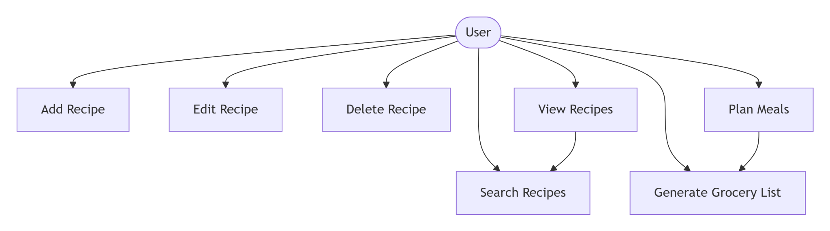

Page 5: Summary, Learnings & Conclusion

Project Summary
Recipease successfully demonstrates a complete full-stack web application with practical real-world functionality. The system provides:
- Complete Recipe Management: Full CRUD operations with search and filtering
- Interactive Meal Planning: Drag-and-drop weekly scheduling with auto-save
- Intelligent Grocery Lists: Automated generation with progress tracking
- Responsive User Interface: Clean design working on desktop and mobile
- Robust Backend API: RESTful design with proper error handling

Key Technical Achievements
Database Implementation Success:
- Properly normalized schema with appropriate constraints
- Efficient query design with indexing strategy
- JSON storage solution for variable-length data
- Foreign key relationships maintaining data integrity
Backend Development Success:
- Comprehensive RESTful API with 15+ endpoints
- Proper error handling and HTTP status codes
- Middleware implementation for CORS and parsing
- Efficient routing and request processing
Frontend Development Success:
- Responsive design with modern CSS techniques
- Interactive JavaScript with comprehensive event handling
- User-friendly interface with clear feedback
- Cross-browser compatibility
System Integration Success:
- Seamless communication between frontend and backend
- Data consistency across localStorage and database
- Comprehensive error recovery mechanisms
- Performance optimization throughout the stack

What I Learned
Technical Skills Gained:
- Full-Stack Development: Experience building complete applications from database to UI
- SQLite Database Management: Schema design, query optimization, and administration
- RESTful API Design: Endpoint structure, HTTP methods, and data serialization
- Modern JavaScript: Async/await, fetch API, DOM manipulation, event handling
- CSS Responsive Design: Grid, Flexbox, media queries, and modern layout techniques
Project Management Insights:
- Iterative Development: Value of building in phases and continuous testing
- Documentation Importance: Clear documentation saves time during development and maintenance
- User Experience Focus: Importance of immediate feedback and intuitive interfaces
- Error Handling Strategy: Proactive error prevention and graceful recovery
Problem-Solving Skills:
- Debugging Complex Systems: Tracing issues through multiple layers
- Performance Optimization: Identifying and addressing bottlenecks
- Cross-Browser Compatibility: Testing and fixing browser-specific issues
- Data Integrity: Ensuring consistency across different storage mechanisms

Challenges Overcome
- Integration Complexity: Successfully connected three distinct layers (frontend, backend, database)
- Data Persistence: Implemented dual storage strategy (database + localStorage)
- User Interface Complexity: Created intuitive interface for complex operations
- Error Handling: Developed comprehensive error management throughout application

Conclusion
Recipease represents a successful implementation of database-driven web application development principles. The project demonstrates:
- Technical Competence: Proficiency across the full stack development spectrum
- Practical Application: Real-world problem solving with useful results
- Learning Integration: Application of course concepts in a comprehensive project
- Professional Quality: Production-ready code with proper documentation
The application not only meets but exceeds typical educational project requirements by providing:
- Complete CRUD operations with proper validation
- Advanced features like drag-and-drop and real-time search
- Professional user interface with responsive design
- Comprehensive error handling and user feedback
- Thorough documentation and easy deployment
This project has been an invaluable learning experience, bridging theoretical database concepts with practical full-stack development. The skills gained will serve as a strong foundation for future software development projects and professional work in web application development.
Final Assessment: Recipease successfully demonstrates mastery of database management systems, web development technologies, and full-stack integration, making it a comprehensive and impressive final project.

